32 Bit File Register System with ALU implemented in Logisim

## Overview

This project implements a 32-bit file register with an Arithmetic Logic Unit (ALU) using Logisim. It is designed for educational purposes to demonstrate the functionality of a basic ALU and register file in digital logic design.

# How to use the project?

**Step 1: Entering Data**



In the ‘WriteData’ field, enter the data in binary.

**Step 2: Writing Data into Register**

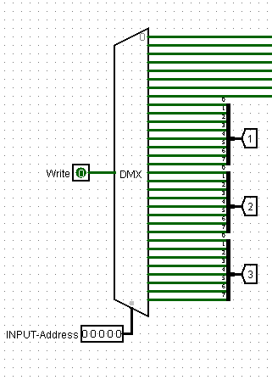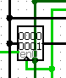

1. Enter an input address in the Address field to select the register where you want to store your data.
2. Turn on the clock.
3. Activate the write button.
4. The data will be stored in the selected register. Initially, all registers are empty and contain zeros.

**Step 3: Printing Data**

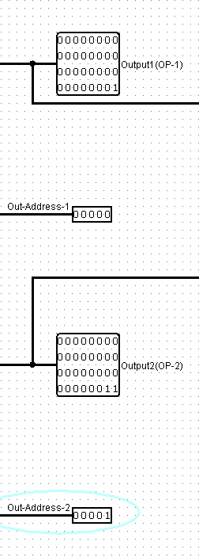

1. Enter the address of the register you used to store the data in the Out-Address field.
2. View the data in Output1 (OP-1) for the first set of data.
3. Repeat for a second register to see the data in Output2 (OP-2).

**Step 4: Operation performed by ALU**

Enter the desired operation code in the four-digit input box to see the output. The operations are as follows:

* NOT: 0000
* AND: 0001
* OR: 0010
* NAND: 0011
* NOR: 0100
* XOR: 0101
* Multiplication: 0110
* Division: 0111

View the result of the operation in the output field.

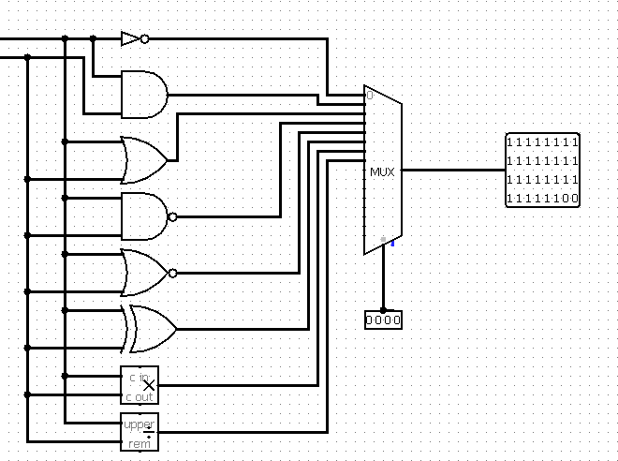

**Example: NOT Operation**

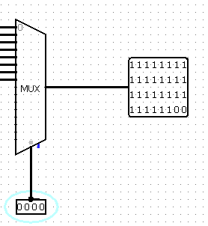

1. Enter 0000 in the input box to perform the NOT operation.
2. Observe the result in the output field.

**Important Notes**

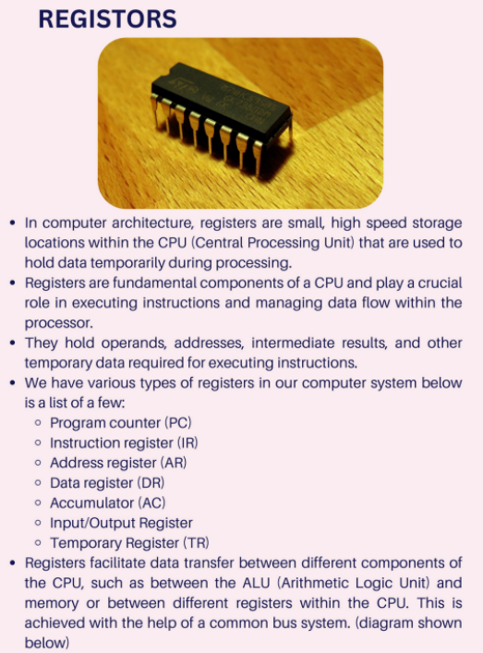

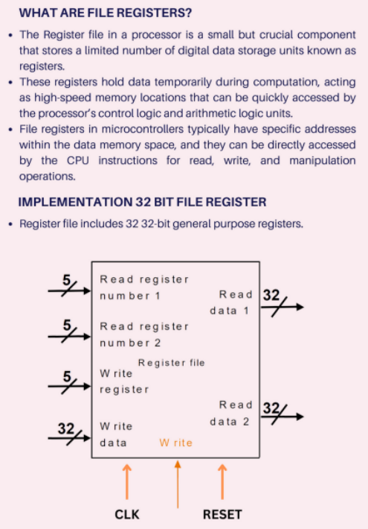

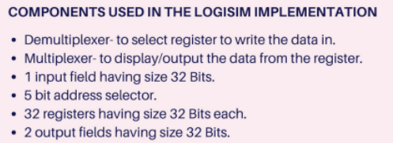

**License**

This project is licensed under the MIT License.

**Additional Information**

For further details on using Logisim, please refer to the [Logisim User Guide](http://www.cburch.com/logisim/).